The TCP/IP model (Transmission Control Protocol/Internet Protocol) is the foundational communication framework used in the internet and most networks today. It consists of four layers, each handling specific aspects of communication.

1. Application Layer
Function:
- Provides network services directly to applications and users.
Protocols:
- HTTP/HTTPS (web browsing)
- SMTP (email sending)
- FTP (file transfers)
- DNS (domain name resolution)
Real-time Example:
You open your browser and visit https://www.google.com.
- Your browser uses HTTP/HTTPS to request the web page.
- DNS resolves "google.com" to an IP address.

2. Transport Layer
Function:
- Manages end-to-end communication, error checking, and data flow control.
Protocols:
- TCP (Transmission Control Protocol – reliable)
- UDP (User Datagram Protocol – faster, but less reliable)
Real-time Example:
Watching a YouTube video vs sending an email:
- YouTube streaming uses UDP for faster delivery, tolerating minor data loss.
- Email uses TCP to ensure all data is received reliably.

3. Internet Layer
Function:
- Handles logical addressing and routing data across networks.
Protocols:
- IP (IPv4/IPv6) – addressing and routing
- ICMP – error messages and diagnostics (e.g., ping)
Real-time Example:
When sending a message from India to the USA:
- The IP protocol breaks it into packets and routes them across the globe.
- If a network issue occurs, ICMP sends an error message.
ICMP is a network-layer protocol used by network devices (like routers) to send error messages and diagnostic information.
- It is not used to send or receive data like TCP or UDP.
- Instead, it reports problems with data delivery across the network.

4. Network Access Layer (a.k.a. Link or Data Link Layer)
Function:
- Manages physical transmission over network media and local addressing.
Technologies:
- Ethernet, Wi-Fi, ARP, MAC addressing
Real-time Example:
When you connect to Wi-Fi at a coffee shop:
- Your device uses Wi-Fi (a Network Access protocol) to send data frames.
- ARP resolves IP addresses to MAC addresses to deliver data locally.
Address Resolution Protocol.
ARP is a network protocol used to map an IP address (logical) to a MAC address (physical) in a local area network (LAN).
Think of it like this:
"If I have someone's name (IP), how do I find their phone number (MAC)?"

Why is ARP Needed?
- Devices communicate using MAC addresses at the data link layer.
- But applications use IP addresses.
- So ARP acts as a bridge between the two.

How ARP Works – Step-by-Step:
- Your device wants to send data to IP 192.168.1.5.
- It checks its ARP cache to see if it already knows the MAC address.
- If not, it sends an ARP Request:
  - “Who has IP 192.168.1.5? Tell me.”
- The device with that IP replies with an ARP Reply:
  - “I have IP 192.168.1.5, and my MAC is aa:bb:cc:dd:ee:ff.”
- Your device stores this info in its ARP cache and sends the data.

In computer networking, transmission modes refer to the direction of signal flow between two connected devices. There are three main transmission modes, each determining how data is sent and received between devices:

1. Simplex Mode
- Definition: Data flows in only one direction.
- Example: A keyboard sends input to a computer; the computer doesn't send data back to the keyboard.
- Use Cases: Television broadcasting, keyboards, traditional radio.

2. Half-Duplex Mode
- Definition: Data flows in both directions, but only one direction at a time.
- Example: Walkie-talkies – only one person can talk at a time.
- Use Cases: CB radios, legacy Ethernet (using hubs), some wireless communications.

3. Full-Duplex Mode
- Definition: Data flows in both directions simultaneously.
- Example: A phone call – both parties can talk and listen at the same time.
- Use Cases: Modern Ethernet (with switches), mobile phones, video conferencing.
switching techniques
In networking, switching techniques determine how data is transferred across the network from sender to receiver. These techniques are essential in both circuit-based and packet-based networks for efficient communication.
There are three primary switching techniques:

1. Circuit Switching
🔹 Explanation:
- A dedicated communication path (circuit) is established between the sender and receiver before data transfer begins.
- The path remains reserved for the entire duration of the communication.
🔹 Characteristics:
- Connection-oriented.
- Fixed bandwidth.
- Suitable for real-time communication.
🔹 Real-Time Example:
- Telephone networks (PSTN): When you make a traditional phone call, a dedicated path is established and maintained until the call ends.

2. Packet Switching
🔹 Explanation:
- Data is broken into small packets.
- Each packet may take a different path to the destination.
- Packets are reassembled at the receiver’s end.
🔹 Characteristics:
- More efficient use of network resources.
- Can experience delays and packet loss.
🔹 Real-Time Example:
- Internet: When you send an email, access a website, or stream video, the data is sent in packets using protocols like TCP/IP.

3. Message Switching
🔹 Explanation:
- Entire messages are sent to intermediate nodes, where they are stored and forwarded to the next node.
- Unlike packet switching, the whole message is kept intact at each node before forwarding.
🔹 Characteristics:
- Store-and-forward technique.
- No need for dedicated path.
- Not suitable for real-time applications due to delay.
🔹 Real-Time Example:
- Email systems (in earlier implementations): A complete message is stored on a mail server before being forwarded to the recipient’s server.

Transmission medium
Transmission media is the physical medium through which data is transmitted from one device to another within a network. These media can be wired or wireless. The choice of medium depends on factors like distance, speed, and interference
What is Transmission Media in Computer Networks?
A transmission media is a physical path between the transmitter and the receiver i.e. it is the path along which data is sent from one device to another.
Transmission Media is broadly classified into the following types:
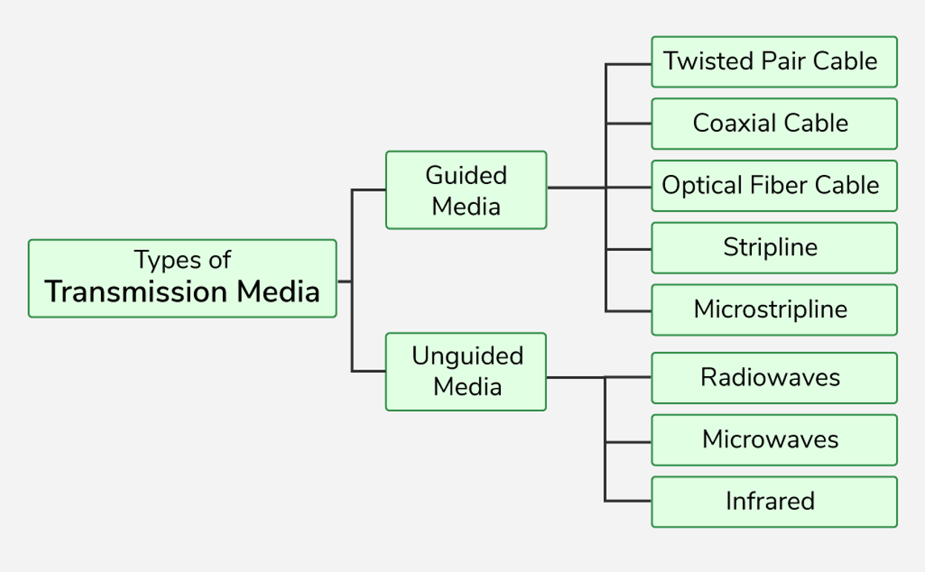
Types of Transmission Media
1. Guided Media
Guided Media is also referred to as Wired or Bounded transmission media. Signals being transmitted are directed and confined in a narrow pathway by using physical links.
Features:
- High Speed
- Secure
- Used for comparatively shorter distances
There are 3 major types of Guided Media:
1.Twisted Pair Cable
It consists of 2 separately insulated conductor wires twisted about each other. Generally, several such pairs are bundled together in a protective sheath. They are the most widely used Transmission Media. Twisted Pair is of two types:
- Unshielded Twisted Pair (UTP):UTP consists of two insulated copper wires twisted around one another. This type of cable has the ability to block interference and does not depend on a physical shield for this purpose. It is used for telephonic applications.

Advantages of Unshielded Twisted Pair
- Least expensive
- Easy to install
- High-speed capacity
Disadvantages of Unshielded Twisted Pair
- Lower capacity and performance in comparison to STP
- Short distance transmission due to attenuation(loss of signal strength as it travels through a medium)
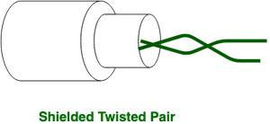
Shielded Twisted Pair (STP): Shielded Twisted Pair (STP) cable consists of a special jacket (a copper braid covering or a foil shield) to block external interference. It is used in fast data rate Ethernet and in voice and data channels of telephone lines.
Advantages of Shielded Twisted Pair
- Better performance at a higher data rate in comparison to UTP
- Eliminates crosstalk(electromagnetic interference or Damaged or old infrastructure)
- Comparatively faster
Disadvantages of Shielded Twisted Pair
- Comparatively difficult to install and manufacture
- More expensive
Coaxial Cable
Coaxial cable has an outer plastic covering containing an insulation layer made of PVC or Teflon and 2 parallel conductors each having a separate insulated protection cover. The coaxial cable transmits information in two modes: Baseband mode(The entire bandwidth of the cable is used by one signal at a time.) and Broadband mode(cable television (and internet) carries many TV channels simultaneously). Cable TVs and analog television networks widely use Coaxial cables.
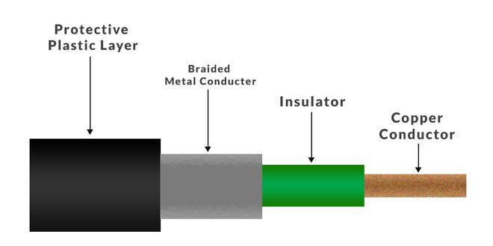
Advantages of Coaxial Cable
- Coaxial cables has high bandwidth .
- It is easy to install.
- Coaxial cables are more reliable and durable.
- Less affected by noise or cross-talk or electromagnetic inference.
- Coaxial cables support multiple channels
Disadvantages of Coaxial Cable
- Coaxial cables are expensive.
- The coaxial cable must be grounded in order to prevent any crosstalk.

- There is a chance of breaking the coaxial cable and attaching a “t-joint” by hackers, this compromises the security of the data.
Optical Fiber Cable
Optical Fibre Cable uses the concept of total internal reflection of light through a core made up of glass. The core is surrounded by a less dense glass or plastic covering called the coating. It is used for the transmission of large volumes of data. The cable can be unidirectional or bidirectional. The WDM (Wavelength Division Multiplexer) supports two modes, namely unidirectional and bidirectional mode.
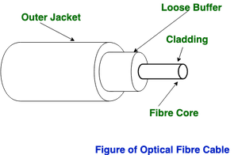
Advantages of Optical Fibre Cable
- Increased capacity and bandwidth
- Lightweight
- Less signal attenuation
- Immunity to electromagnetic interference
- Resistance to corrosive materials
Disadvantages of Optical Fibre Cable
- Difficult to install and maintain
- High cost
Applications of Optical Fibre Cable
- Medical Purpose: Used in several types of medical instruments.
- Defence Purpose: Used in transmission of data in aerospace.
- For Communication: This is largely used in formation of internet cables.
- Industrial Purpose: Used for lighting purposes and safety measures in designing the interior and exterior of automobiles.
2. Unguided Media
It is also referred to as Wireless or Unbounded transmission media . No physical medium is required for the transmission of electromagnetic signals.
Features of Unguided Media
- The signal is broadcasted through air
- Less Secure
- Used for larger distances
There are 3 types of Signals transmitted through unguided media:
Radio Waves
Radio waves are easy to generate and can penetrate through buildings. The sending and receiving antennas need not be aligned. Frequency Range:3KHz - 1GHz. AM and FM radios and cordless phones use Radio waves for transmission.
Types of Radio Waves:
- Short Wave: AM Radio
- VHF (Very High Frequency): FM Radio/TV
- UHF (Ultra High Frequency): TV
AM radio ranges from 535 to 1705 kilohertz, whereas FM radio ranges in a higher spectrum from 88 to 108 megahertz.
Radio Wave Components:
- Transmitter: Responsible for encoding the signal.
- Receiver: Responsible for decoding the signal.

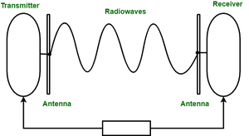

Microwaves
It is a line of sight transmission i.e. the sending and receiving antennas need to be properly aligned with each other. The distance covered by the signal is directly proportional to the height of the antenna. Frequency Range:1GHz - 300GHz. Micro waves are majorly used for mobile phone communication and television distribution.
Example:DTH (delivers satellite TV signals directly to a viewer's home via a personal dish antenna.)
Advantages:
- Cheaper than using cables
- Freedom from land acquisition
- Ease of communication in difficult terrains
- Communication over oceans
Disadvantages:
- Insecure communication.
- Out of phase signal.
- Susceptible(easily affected) to weather conditions.
- Bandwidth is limited.
- High cost of design, implementation, and maintenance.

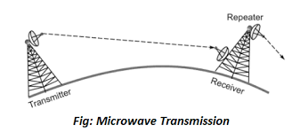
Infrared
Infrared waves are used for very short distance communication. They cannot penetrate through obstacles. This prevents interference between systems. Frequency Range:300GHz - 400THz. It is used in TV remotes, wireless mouse, keyboard, printer, etc.
